# A Dual-function Switchable Metasurface Terahertz Device Design Assisted by Random Forest

Lipengan Ye†a, Yunpeng Yao†b, Wei Sua*, Zongli Huc, Jiang Yuea, and Hongbing Yaoa**

a *College of Mechanics and Engineering Science, Hohai University, Nanjing, 210098, China*

b *The University of Queensland, Faculty of Engineering, Architecture and Information Technology, St Lucia QLD 4067, Queensland, Australia*

c *Changzhou University, School of Microelectronics and Control Engineering, 213164, Changzhou, China*

*† These authors contributed equally to this work and can be considered as co-first authors.*

*corresponding author: opticsu@hhu.edu.cn; alenyao@hhu.edu.cn

**Abstract:** With the terahertz wave being widely used for its characteristics, the limitations of single-function terahertz metasurface devices can no longer meet the growing demand, so the attention turns to terahertz metasurface devices with composite functions. This study presents a multifunctional terahertz metasurface device integrating graphene and vanadium dioxide (VO2). Capitalizing on the electrically tunable chemical potential of graphene and the thermally activated phase transition of VO2, the proposed device enables on-demand functional switching. When VO2 is maintained in its dielectric state through temperature control, the device operates in polarization manipulation mode, achieving broadband cross-polarization conversion with a polarization conversion ratio (PCR) exceeding 90% across 6.241~10 THz. Conversely, thermal transition of VO2 to its metallic state activates the terahertz absorption mode, demonstrating over 90% effective absorption within 2.088~4.756 THz and perfect absorption at 3.985 THz. The design process incorporates machine learning-assisted metasurface optimization, significantly reducing conventional trial-and-error workloads. Comprehensive theoretical analysis, including electromagnetic field simulations and equivalent circuit modeling, systematically elucidate the device's operational mechanisms. Furthermore, the proposed structure exhibits exceptional performance metrics: the thin profile, broadband spectral response, polarization insensitivity, and robust operation under large-angle incidence. These combined advantages position the device as a promising platform for next-generation reconfigurable terahertz systems.

**Keywords:** Terahertz, Metasurface, Absorber, Polarization conversion, Machine Learning, Random Forest

1. Introduction

As a member of the family of Electromagnet waves, the Terahertz (THz) waves, occupying the frequency range of 0.1 to 10 THz1 between microwave and infrared regions, exhibit unique electromagnetic properties. With the advancement of ultrafast technologies in recent decades, THz wave technology and its applications have witnessed significant development2-9. The growing sophistication of THz technologies has created an increasing demand for high-precision THz detectors. Metasurface devices, owing to their distinctive characteristics, have demonstrated remarkable potential in achieving high-sensitivity and broadband-responsive THz detection, thus gaining extensive research attention. Metasurfaces, an artificially engineered periodic structures, offer precise control over electromagnetic parameters including wavelength, phase, amplitude,10-12 and particularly polarization states13-15 and have emerged as promising platforms for sensitive, broadband THz detection. Unlike conventional bulky optics, metasurface devices enable substantial miniaturization of polarization components, outperforming traditional plates in applications.

By adding external excitation tuning materials such as graphene and vanadium dioxide (VO2) to the device, the device can realize functional switching. As a phase-change material, VO2 enables multifunctional integration in metasurfaces through its thermally induced insulator-to-metal transition. The distinct dielectric properties of VO2 in different phases facilitate switchable functionalities between polarization conversion and electromagnetic wave absorption16-18.

The design of metasurfaces presents substantial challenges due to complex electromagnetic interactions between structural parameters and THz waves. Conventional optimization methods relying on directional derivative approaches require extensive computational resources and prolonged design cycles. Machine learning-assisted prediction methods offer a promising solution by automatically determining optimal structural parameters through dataset construction and algorithmic learning. As an emerging data analysis technique, machine learning has demonstrated considerable potential in replacing manual operations and has found preliminary applications in metasurface design19-23.

This study proposes a terahertz metasurface device based on a dielectric sandwich element (DSE) architecture, capable of dual-mode operation combining transmission-type polarization manipulation and electromagnetic wave absorption. Machine learning algorithms were employed to predict absorption bandwidth and corresponding structural parameters. When VO2 is in the dielectric and metallic states, the device will operate in polarization modulation and terahertz absorption modes respectively, achieving different modulation of electromagnetic waves. Furthermore, comprehensive theoretical analyses including equivalent circuit modeling and field distribution simulations were conducted to elucidate the operational mechanisms.

1. Model and theory

As illustrated in Figure 1, the proposed terahertz metasurface comprises a four-layer unit cell architecture. From bottom to top, the structure consists of: (1) a lower polyethylene cycloolefin olefin copolymer (TOPAS) substrate, (2) a VO2-Au composite layer, (3) an upper TOPAS layer, and (4) a square graphene patch. The VO2-Au composite layer features two symmetric arrowhead-shaped gold embedded within a VO2 matrix. The geometric parameters are defined as follows: *P* represents the unit-cell periodicity, *d* denotes the side length of the square graphene patch, *h*1​ and *h*2​ correspond to the thicknesses of the lower and upper TOPAS dielectric layers respectively, *t* specifies the thickness of the VO2-Au composite layer, while *L* and *l* characterize the dimensions of these gold arrowhead, representing the situation of their outer and inner vertices respectively.

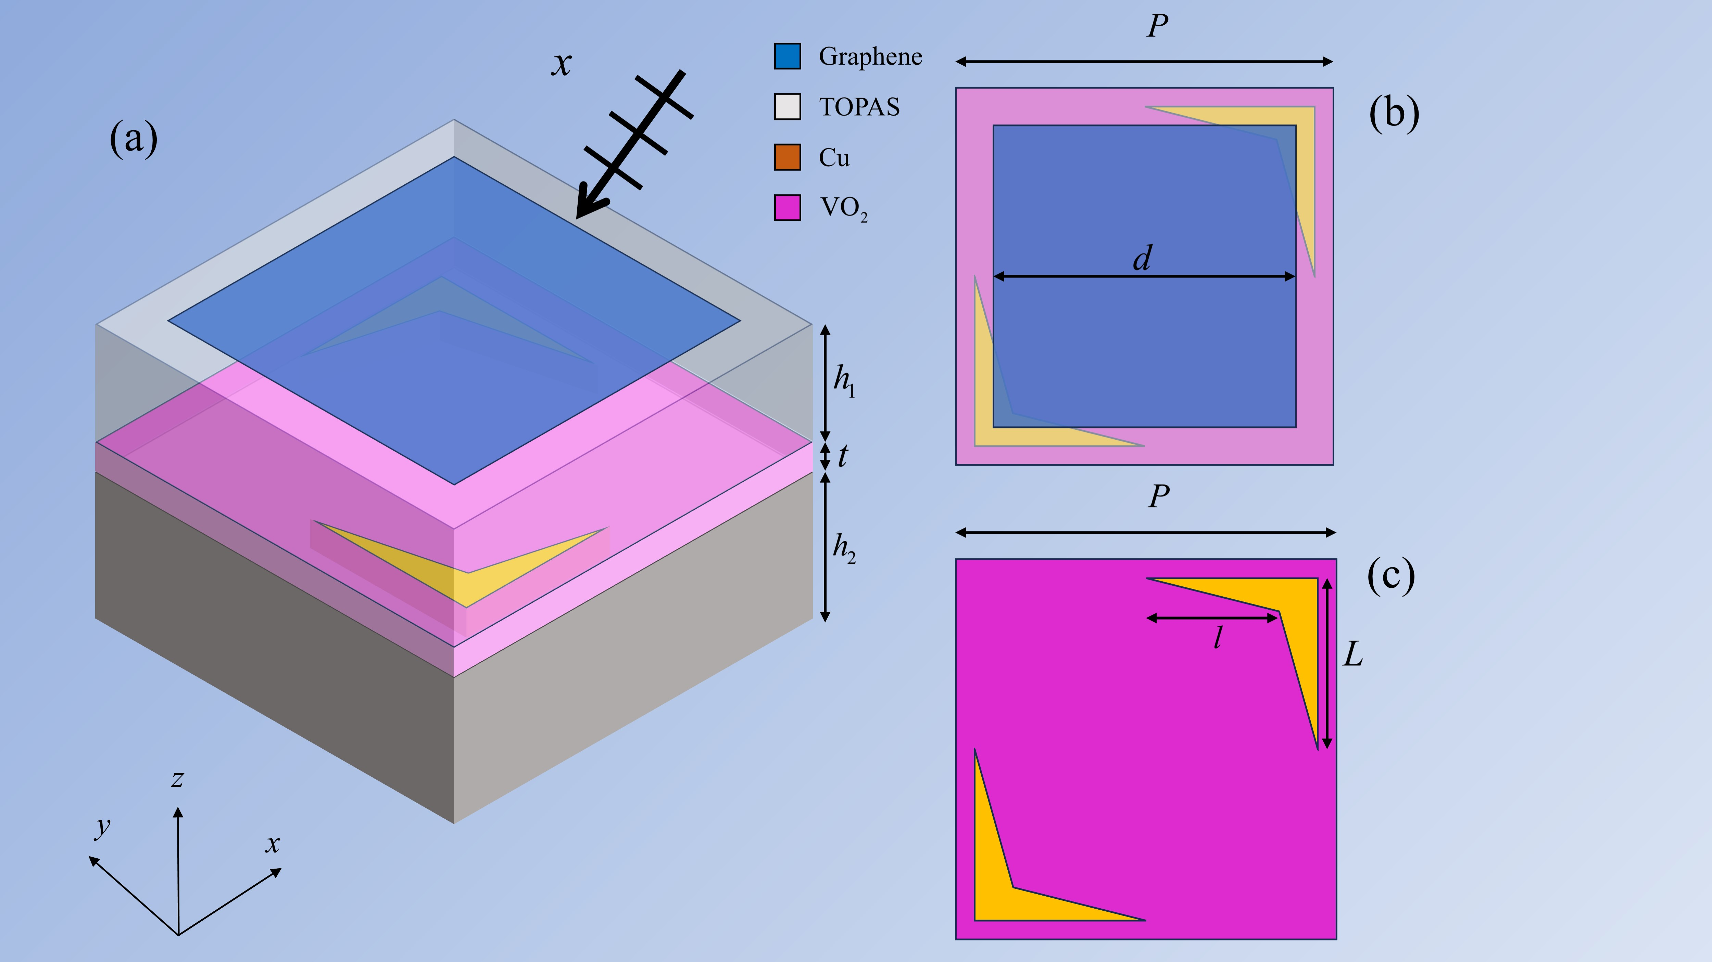

**Fig. 1.** Schematic diagram of the proposed DSE structure. (a) Unit structure, (b) Top view of the upper surface, (c) Schematic diagram of the VO2-Au layer.

The Kubo formula can describe the photoelectric properties of graphene24:





where the used symbols *T* denote the thermodynamic temperature, the *ω* is angular frequency, and the *µ*c chemical potential, respectively. The Fermi-Dirac distribution is denoted by the symbol *fd*, while *Γ* signifies the scattering rate. Fix *µ*c at 1 eV25. The *vf* denotes the Fermi velocity. Carrier mobility governs the relaxation time when *µc* is constant. Additionally, *Γ* and *T* are assigned values of 0.0082 eV and 300 K, respectively.

In the terahertz regime, the conductivity of VO₂ in its metallic phase is governed by the Drude model, expressed as 26, 27:



where the *ε∞* = 12, the collision frequency *γ* is 5.75×1013 rad/s, and the plasma frequency *ωp*(*σ*) can be calculated by:



where the reference conductivity *σ*0= 3×105 S/m, the plasma frequency *ωp*(*σ*0) = 1.4×1015 rad/s28.

Numerical simulations adopted specific material properties: the TOPAS substrate exhibits a lossless refractive index of *n* = 2.3529, while gold conductivity was fixed at 4.56×107 S/m30. For vanadium dioxide (VO2), phase-dependent conductivities were prescribed at 2×10⁵ S/m (metallic phase) and 10 S/m (insulating phase)31.

Absorption characteristics and polarization effects of the DSE were simulated using the finite-difference time-domain (FDTD) approach. The computational domain featured terahertz wave excitation propagating along the negative *z*-axis, with periodic boundaries imposed on *xy*-planes and Perfectly Matched Layers (PMLs) applied at *z*-boundaries to suppress numerical reflections. Frequency-domain monitors were deployed at transmission and reflection interfaces to quantify electromagnetic wave components.

1. ML analysis
   1. *RF algorithm principle*

Random Forests (RF) is an ensemble classification and regression algorithm which is powerful for solving various ML tasks and has been widely validated by both theoretical and empirical research32-34. Generally speaking, as shown in Figure (2), during RF generation process, bootstrap resampling is first performed on training sets so that *K* sample subsets(n_estimators=*K*) are generated, each used to train a decision tree. Next, every subset of features from all available features is randomly selected at each node split of a tree so that the best split point can be chosen. Thirdly, each decision tree is independently constructed based on the sampled subsets and features that are randomly selected. Finally, the decision trees merge into RF and the average of the predictions from all trees are calculated as the final output.

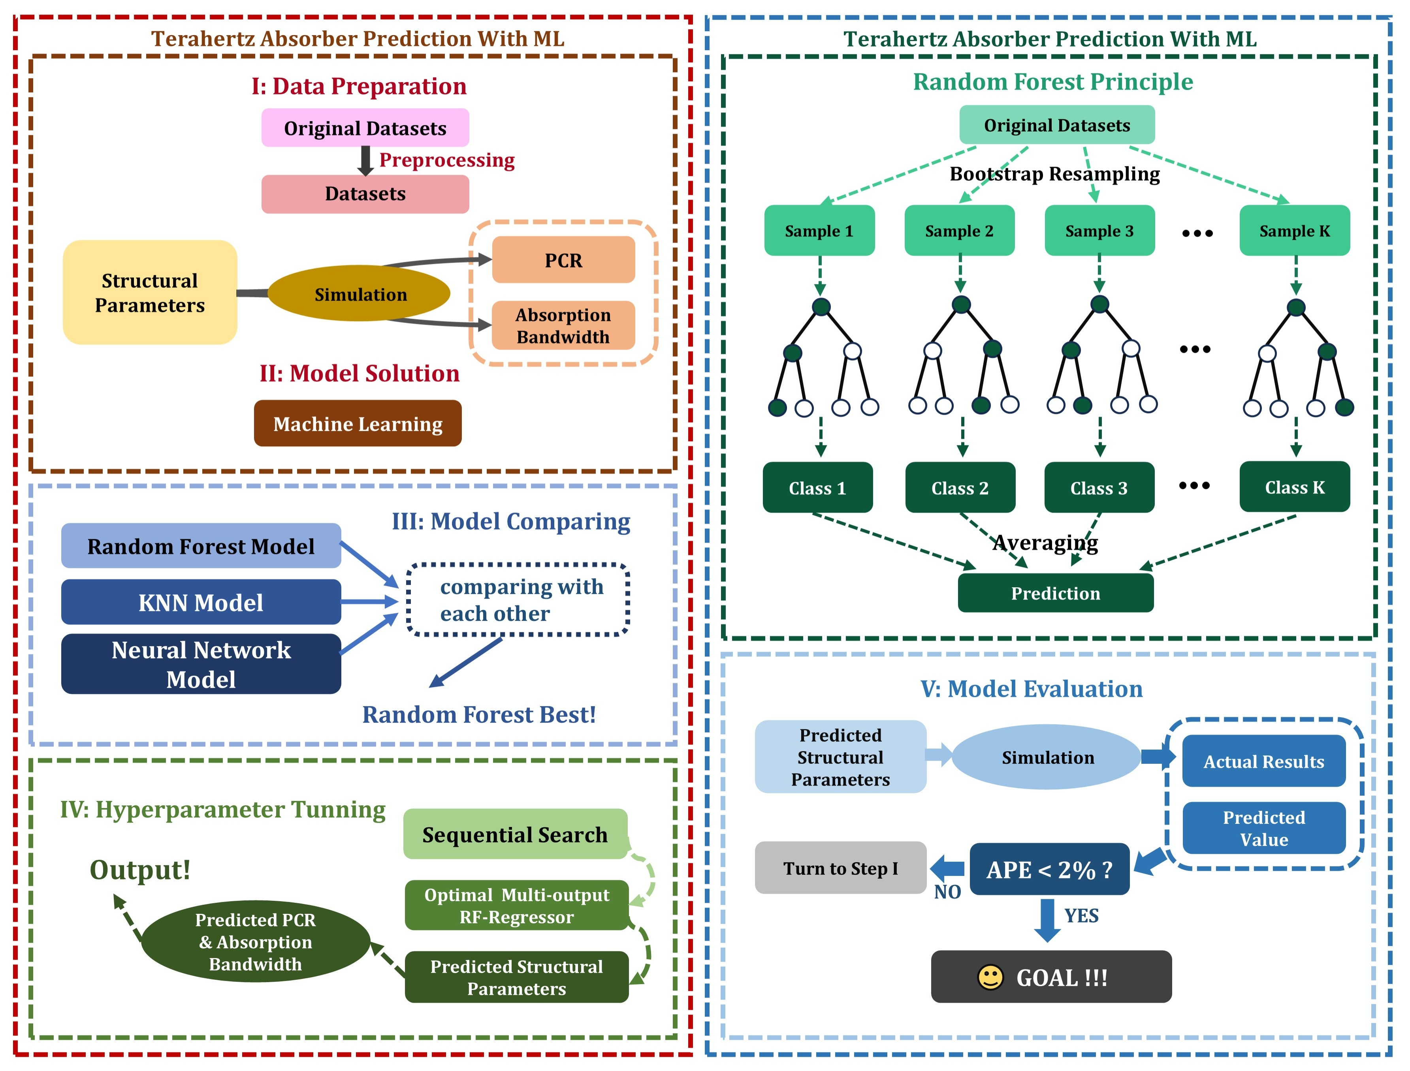

**Fig. 2.** Schematic diagram of the process of machine learning prediction.

To be more specific, the construction and splitting of all decision trees in our program are typically based on the MSE metrics(model.criterion=squared_error):



where *yi*,  and *N* denotes the true value, the predicted value and the number of samples respectively.

During tree construction, every feature and its candidate split points (e.g., midpoints of feature values) are evaluated by computing the resulting mean squared error (MSE). The feature–split combination that yields the lowest MSE is chosen. This procedure is then applied recursively to the left and right child nodes until a stopping criterion is met (e.g., maximum depth or minimum sample count). Finally, each leaf node’s prediction is set to the mean of the true target values of the samples it contains.

The RF algorithm integrates multiple weak decision trees into a robust ensemble, reducing random errors and enhancing tolerance to outliers and noise, which improves predictive accuracy, stability, and robustness while resisting overfitting. In the design of ultra-broadband terahertz absorbers, where graphene and TOPAS involve numerous structural parameters, the RF regression algorithm leverages randomness—through randomly generated decision trees and feature subsets—to minimize tree correlations and optimize parameter selection objectively. This approach overcomes the subjectivity and bias of manual parameter selection, significantly improving prediction accuracy and reliability for PCR, absorption bandwidth and structural parameters.

* 1. *RF-regressor prediction*

Manually making multiple trails using simulation software to predict and design the terahertz absorber is nearly impossible because the EM phenomena is so complex. Also, manually changing the parameter combination is random and inaccurate, consuming a significant amount of time and effort. Therefore, ML is introduced. To be more specific, the original dataset has several columns are structural parameters, PCR and absorption bandwidth. All the structural parameters have their certain ranges with their step size. The structural parameters combinations are simulated based on FDTD method to predict Absorption bandwidth and PCR. When the original dataset is ready, all these data are fed into Multi-output RF-regressor after splitting into training-set and test-set.

**Tab. 1.** The parameter variables selection of DSE

|  |  |  |
| --- | --- | --- |
| Parameter | Range (µm) | Accuracy (µm) |
| *h*1 | 10.00~20.00 | 0.01 |
| *h*2 | 10.00~20.00 | 0.01 |
| *L* | 1.0~10.0 | 0.1 |
| *l* | 1.0~10.0 | 0.1 |
| *t* | 0.0~2.00 | 0.01 |
| *d* | 0~20.0 | 0.1 |
| *P* | 10.0 | — |

During the ML process, other algorithms are compared with RF, such as KNN and Neural Network. By calculating *R*2, we finally choose RF as our regressor. Also, hyperparameter tuning is applied to optimize the model, these will be carefully described in the next section.

The Multi-output RF-regressor will predict the certain absorption bandwidth and PCR, with its corresponding structural parameters combination. The detailed prediction process is as follows. Firstly, certain input ranges and step sizes are manually set. After the first predictions are calculated, the input ranges or structural parameters can be narrowed down as well as their step sizes more precise. When the RF-regressor cannot get better PCR and absorption bandwidth, the ML prediction process terminates. The optimized parameters are then simulated to obtain actual absorption bandwidth and PCR. Model performance is evaluated by comparing ML-predicted and simulated outputs via absolute percentage error (APE). If APE > 2%, the predicted parameters and simulation results augment the training dataset for iterative re-prediction. Otherwise (APE ≤ 2%), the error of prediction is fall within acceptable tolerance.

* 1. *Optimization of RF-regressor*

To ensure the effectiveness and reliability of our RF-regressor, it is essential to incorporate evaluation metrics. The coefficient of determination (*R*²) is used to assess the strength of the relationship between the predictions and the actual target values:



where *yi* is the actual value of the i-th sample,is the predicted value of the i-th sample,  is the mean of the target variable, and *N* is the number of samples.

As a multiple-output model, both PCR and Absorption Bandwidth are predicted. So the evaluation metrics are set as:



The default model has a relatively high *R*2avg which is 0.9802 compared to other algorithms, but this is not the best RF model. To get the optimal Multi-output RF-regressor, hyperparameter tunning is a must. We use Grid Search to find optimal hyperparameters, however there are multiple combinations share the same *R*2avg. Figure 3 shows the contour plot based on GridSearchCV in Scikit-learn library. We can clearly see that the n_estimator must exceed 25 and max_depth must exceed 10, otherwise the precision of the model would be very poor.

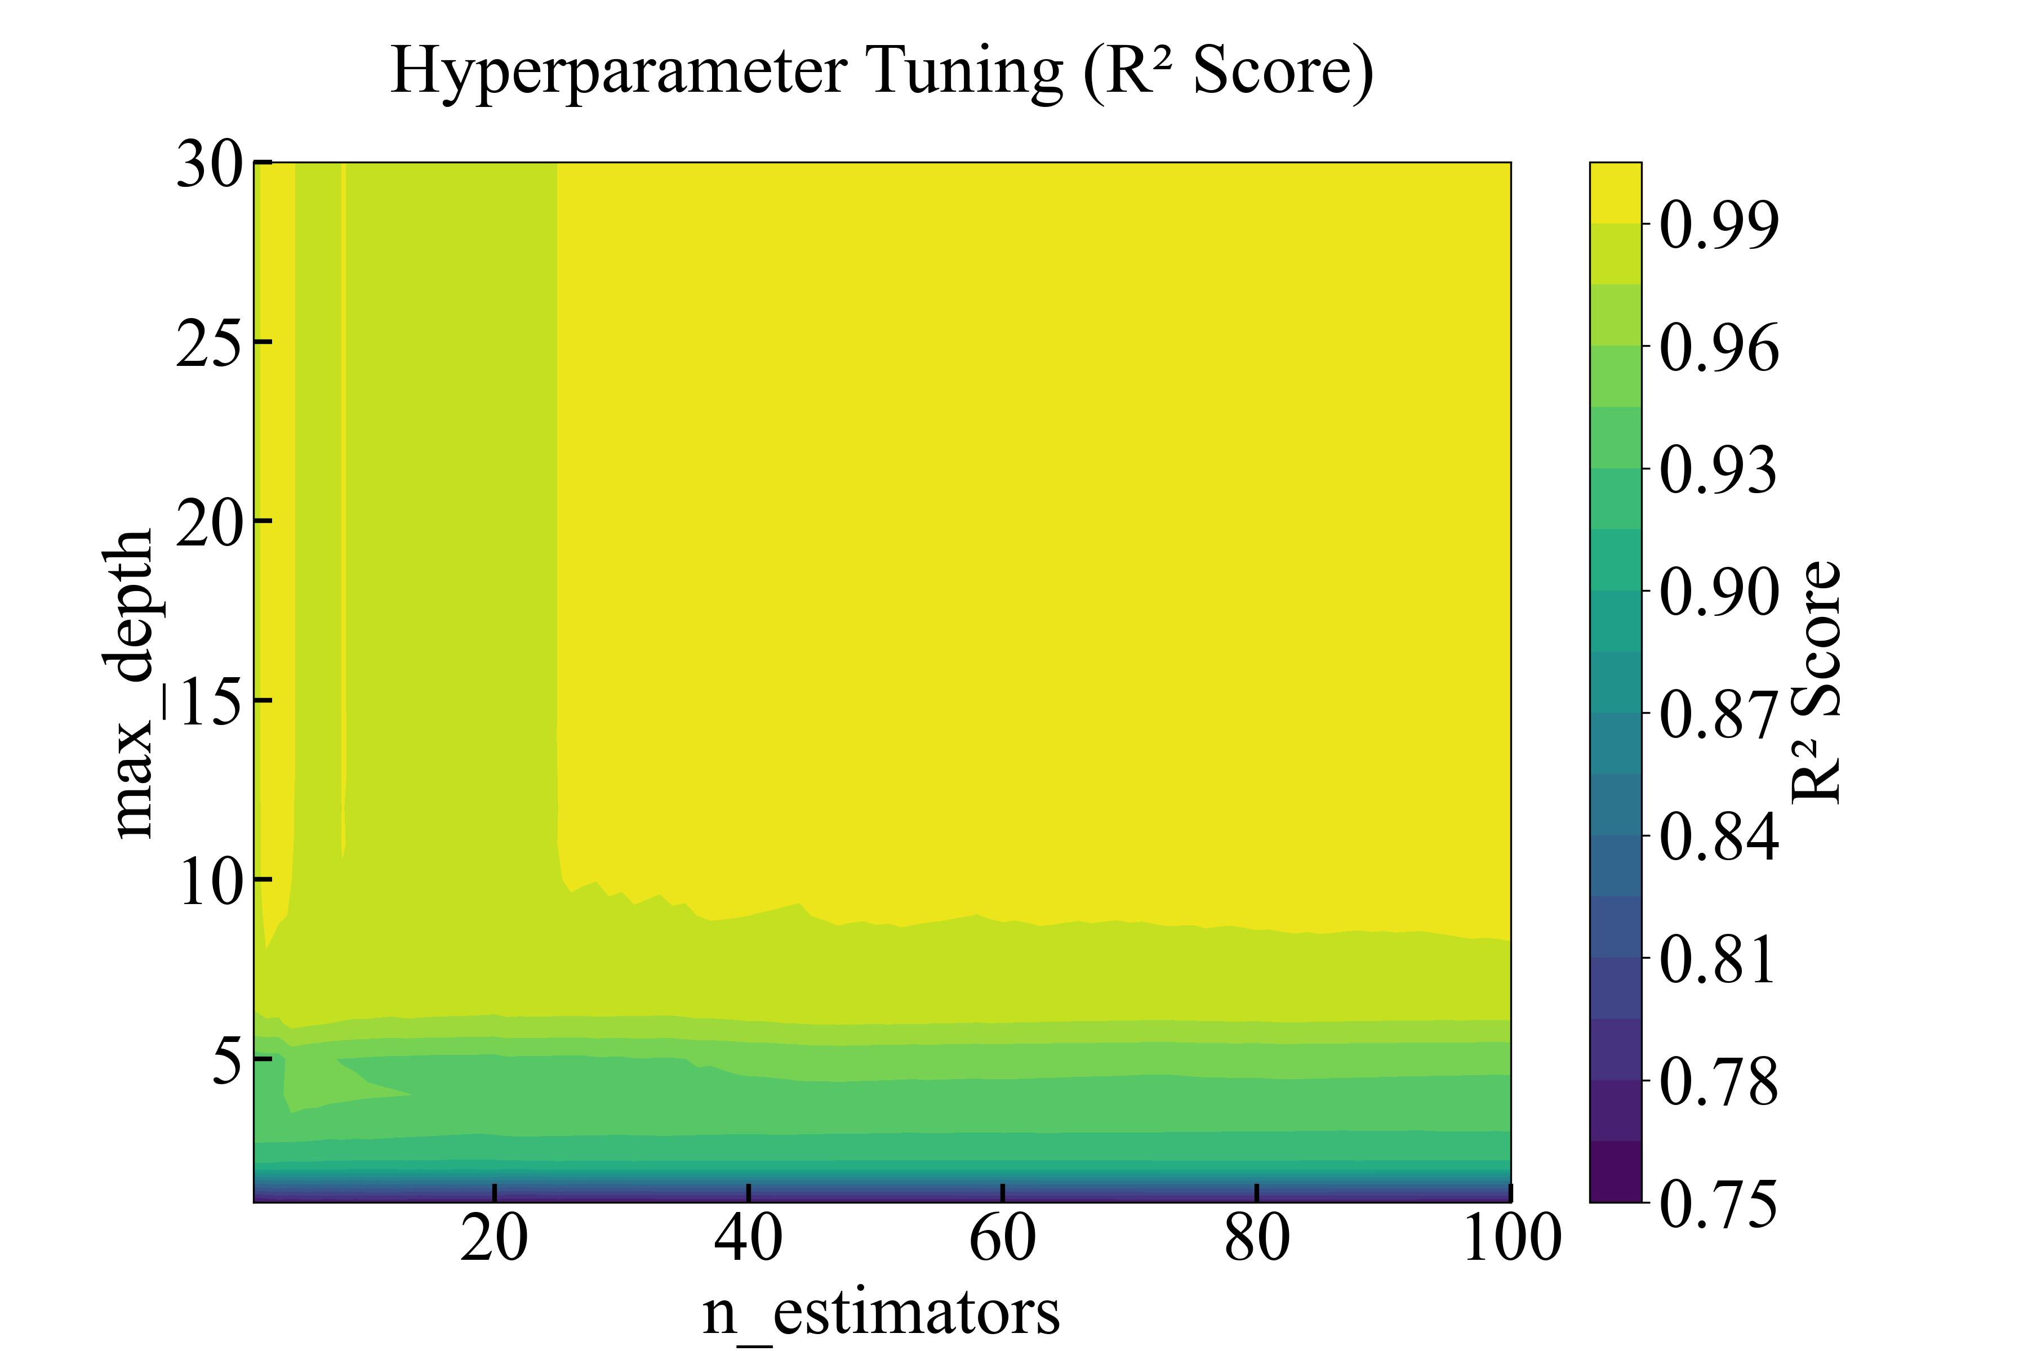

**Fig. 3.** The contour plot based on GridSearchCV in Scikit-learn library.

To determine a certain combination of hyperparameters, we use Sequential Search and only consider the four most important hyperparameters which are n_estimators, max_depth, min_samples_split and min_samples_leaf. The program firstly search the best n_estimator sequentially, then it fixes the n_estimator and search next hyperparameter until all the hyperparameters are confirmed. By iteratively calculating *R*2avg of every model, we finally choose the four hyperparameters as (128, 10, 7, 2) and the *R*2avg of the optimal model reaches 0.9976 which is very good. Figure 4(a)~(d) shows the process and result of the hyperparameter tuning.

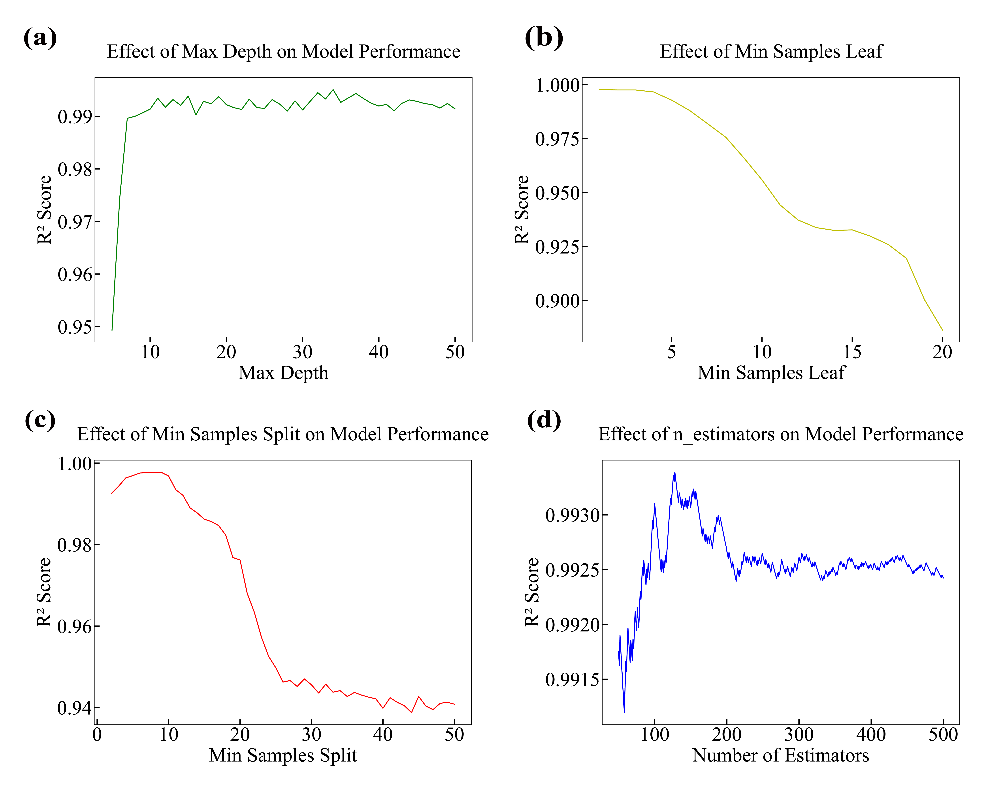

**Fig. 4 .** Schematic diagram of RF hyperparameter optimization (a)Max Depth, (b)Min Samples Leaf, (c)Min Samples Split and (d)n_neighbors.

* 1. *Comparison with other ML methods*

To evaluate the effectiveness of RF in predicting absorption bandwidth and PCR, we trained and compared three additional models—Support Vector Machines (SVM), Neural Networks (NN), and K‑Nearest Neighbors (KNN) 35-38—against the RF.

*R*² were calculated to verify the precision of these models. By comparison, when using Neural Network, *R*² for PCR prediction is only 0.8620 and *R*² for absorption bandwidth prediction is only 0.9527. When using KNN as regressor, *R*2PCR drop to 0.8499 and *R*2absorption drop to only 0.8436. The poorest model is SVM, which has only 0.7841 for *R*2PCR and its *R*2absorption even drop to only 0.6253. All these models are very poor compared to RF whose *R*2avg is high above 0.99.

**Tab. 2.** The Prediction Result of different Algorithms

|  |  |  |  |  |  |  |  |  |  |
| --- | --- | --- | --- | --- | --- | --- | --- | --- | --- |
| Type of Algorithm | *h*1  (µm) | *h*2  (µm) | *L*  (µm) | *l*  (µm) | *t*  (µm) | *d*  (µm) | Predicted (PCR/A) | Actual Value | APE |
| RF | 13.96 | 11.01 | 9 | 8 | 1.55 | 16.6 | 3.80307/2.678 | 3.759/2.668 | 1.54% |
| NN | 12 | 10 | 9.9 | 8 | 2 | 16.3 | 2.6138/2.3836 | 3.184/2.597 | 26.1% |
| KNN | 11 | 10 | 9 | 8 | 1 | 16 | 2.6282/2.9376 | 3.102/2.04 | 59.2% |
| SVM | 11 | 10 | 9 | 8 | 1 | 16 | 2.3262/2.081 | 3.102/2.04 | 27.0% |

* 1. *Results and discussion*

The optimal structural parameter combination predicted by the model is (14, 11, 9, 8, 1.55, 16.6), showcasing exceptional performance with a predicted PCR of 3.80307 and an absorption bandwidth of 2.678. The prediction accuracy is remarkably high, as indicated by an APE of less than 2%, which fully aligns with our expectations for prediction precision learning.

During the machine learning process, the Google Cloud Platform (GCP) and Docker container technology were employed to build a SPARK environment, significantly optimizing and accelerating the prediction process. Given the vast number of structural parameter combinations (exceeding ten million), the Joblib library was utilized to parallelize computations, reducing the total training and prediction time to just half an hour. Without such parallelization, the process could have taken more than ten hours. Moreover, if these simulations were conducted manually, the time required could extend to several months. Thus, the integration of machine learning has proven to be highly effective in addressing such complex and time-intensive problems.

1. Results and discussions
2. *Polarization Conversion mode*

In its dielectric state at room temperature, the DSE operates in polarization manipulation mode by maintaining graphene's chemical potential at 0 eV through voltage regulation, thereby minimizing THz wave absorption.

For an *x*-polarized incident wave, the transmitted wave is expressed as:



where *txx* and *tyx* indicate the transmission coefficient. The *txx* means the incident wave is *x*-polarized and the transmitted wave is also *x*-polarized, and the *txy* means the incident wave is *x*-polarized and the transmitted wave is deflected *y*-polarized. The *φxx* and *φyx* are the corresponding phases. The phase difference



is often used to determine the shape and chirality of a composite wave. Define the polarization conversion ratio PCR:



and the ellipticity *e*:



to measure the device's ability to convert polarised light.



**Fig. 5.** (a) Transmission coefficients, (b) PCR, (c) Polarization rotation angle, (d)Ellipticity ratio, (e) Phase and phase difference of the converter. (f) The UV decomposition diagram. (g) Transmission coefficients and (h) Phase and phase difference of *tuv* and *tvu*.

As demonstrated in Figure 5(a), under *x*-polarized wave incidence, the cross-polarized transmission coefficient *Tyx*​ exhibits a sharp increase followed by gradual attenuation above 5.75 THz, while the co-polarized transmission *Txx* rapidly diminishes to zero. The PCR consistently exceeds 0.9 within the 6.241~10 THz range, indicating complete suppression of residual *x*-polarized components and predominant *y*-polarized transmission. Notably, the PCR approaches 100% above 6.6 THz, demonstrating near-perfect linear-to-cross-linear (LTX) polarization conversion. Complementary analyses reveal key polarization characteristics: Figure 5(c) shows-maintained polarization conversion angles at ±90°, Figure 5(d) displays ellipticity fluctuations near zero, and Figure 5(e) confirms 90° or 270° phase differences between orthogonal components, collectively verifying cross-polarization dominance in this spectral regime.

A linear-to-circular (LTC) conversion is observed near 4.5 THz, where *Tyx*≈*Txx* in Figure 5(a) coincides with unit ellipticity in Figure 5(d) and 90° phase retardation in Figure 5(e), suggesting LTC polarization conversion. However, since the transmittance here is relatively small at only 0.2, the loss of incident electromagnetic waves is relatively large, and the LTC capability is not as practical as the LTX.

The polarization conversion capability comes from the anisotropy of DSE. Since the vanadium dioxide-gold layer is not symmetrical in the *x* or *y* direction, the polarized wave can be decomposed into u and v directions. The decomposition is shown in Figure 5(f). The incident polarized wave is decomposed into two components on the *u* axis and the *v* axis. The transmittance of the *u* wave and the *v* wave is shown in Figure 5(g). Since *tuu* and *tvv* are 0 in the frequency range, it is only necessary to examine the transmittance and phase of *tuv* and *tvu*. In the main working band of 6.241~10THz, it can be considered that the *u* wave and the *v* wave are rotated 90° in this range and are converted into *v* wave and *u* wave respectively. The synthesized transmitted wave is deflected 90° relative to the original incident wave to cause cross polarization.

1. *Terahertz wave absorb mode*

By utilizing the temperature-controlled phase transition characteristics, heating above 68°C transitions VO2 into its metallic state, enabling the device to operate in absorption mode. It should be noted that in absorption mode, due to the skin effect of electromagnetic waves, terahertz waves cannot penetrate the VO2-Au bilayer, rendering the lower TOPAS layer non-participatory in terahertz wave absorption. Under these conditions, the DSE effectively functions as a classical metasurface absorber structure.



**Fig. 6.** (a) Absorption spectrum obtained by FDTD simulation. (b) Relative impedance of DSE. DSE electric field distribution in the *xy* plane at (c) *z* = 0 and (d) *z* = 13.96. DSE electric field distribution in the *yz* plane at (e) *x* = 0 and (f) *x* = 8.4.

In the simulated absorption spectrum of the DSE (shown in Figure 6a), the absorption exceeds 90% from 2.088 to 4.756 THz with a 2.668 THz bandwidth, defined as the effective absorption band. At 3.985 THz, absorption peaks near 100%, achieving “perfect absorption” with virtually no reflection or transmission. Impedance‑matching theory explains this behavior: as shown in Figure 6b, the normalized impedance’s real part approaches 1 and its imaginary part approaches 0 across the absorption band. This near–free‑space matching minimizes reflections at the air–absorber interface, allowing the incident THz waves to enter the DSE and dissipate their energy internally.

The electric field distribution illustrates the electromagnetic wave absorption mechanism of the DSE. Graphene-mediated surface plasmon resonances (SPRs) 39 convert incident radiation into confined in-plane waves, enabling efficient energy dissipation. As shown in the electric field distribution diagrams of the DSE in Figure 6(c)~(f), all four subfigures depict field distributions at the perfect absorption frequency of 3.985 THz across different planes. Figure 6(c)~(d) visualize *xy*-plane field confinement on VO2-Au and graphene surfaces, while Figure 6(e)~(f) reveal the *z*-axis field variations across the central of the graphene and peripheral regions. The analysis reveals that the square graphene patch confines most of the electric field within its plane. Since the incident wave is a plane wave, the electric field distribution on graphene exhibits variations along the *x*-direction, with field concentration observed at the *x*-direction edges of the graphene. In the VO2-Au layer, weak electric fields are localized at the Au- VO2 interfaces, arising from the combined effects of boundary conditions (due to conductivity differences between Au and VO2) and the skin effect.

Electrically controlled absorption is achieved through graphene conductivity modulation, where external voltage variations induce chemical potential shifts that reconfigure wave-matter interactions. Figure 7(a) demonstrates the evolution of the DSE absorption spectrum as the graphene chemical potential is tuned from 0 eV to 1 eV. Notably, reducing the chemical potential weakens the absorption capability, with the peak absorption rate decreasing from near-perfect absorption (~100%) to approximately 29%, achieving a 71% modulation depth. This tunability enhances the DSE’s versatility for diverse absorption requirements.

Given the practical challenges of achieving perfectly normal incidence, oblique incidence scenarios were investigated. As shown in Figure 7(b)~(c), although the absorption bandwidth narrows with increasing incident angles, the DSE maintains absorption bandwidths of 0.814 THz (TE polarization) and 1.311 THz (TM polarization) even at a 60° incidence angle. These results confirm the strong angular robustness and insensitivity to large-angle oblique incidence of DSE.

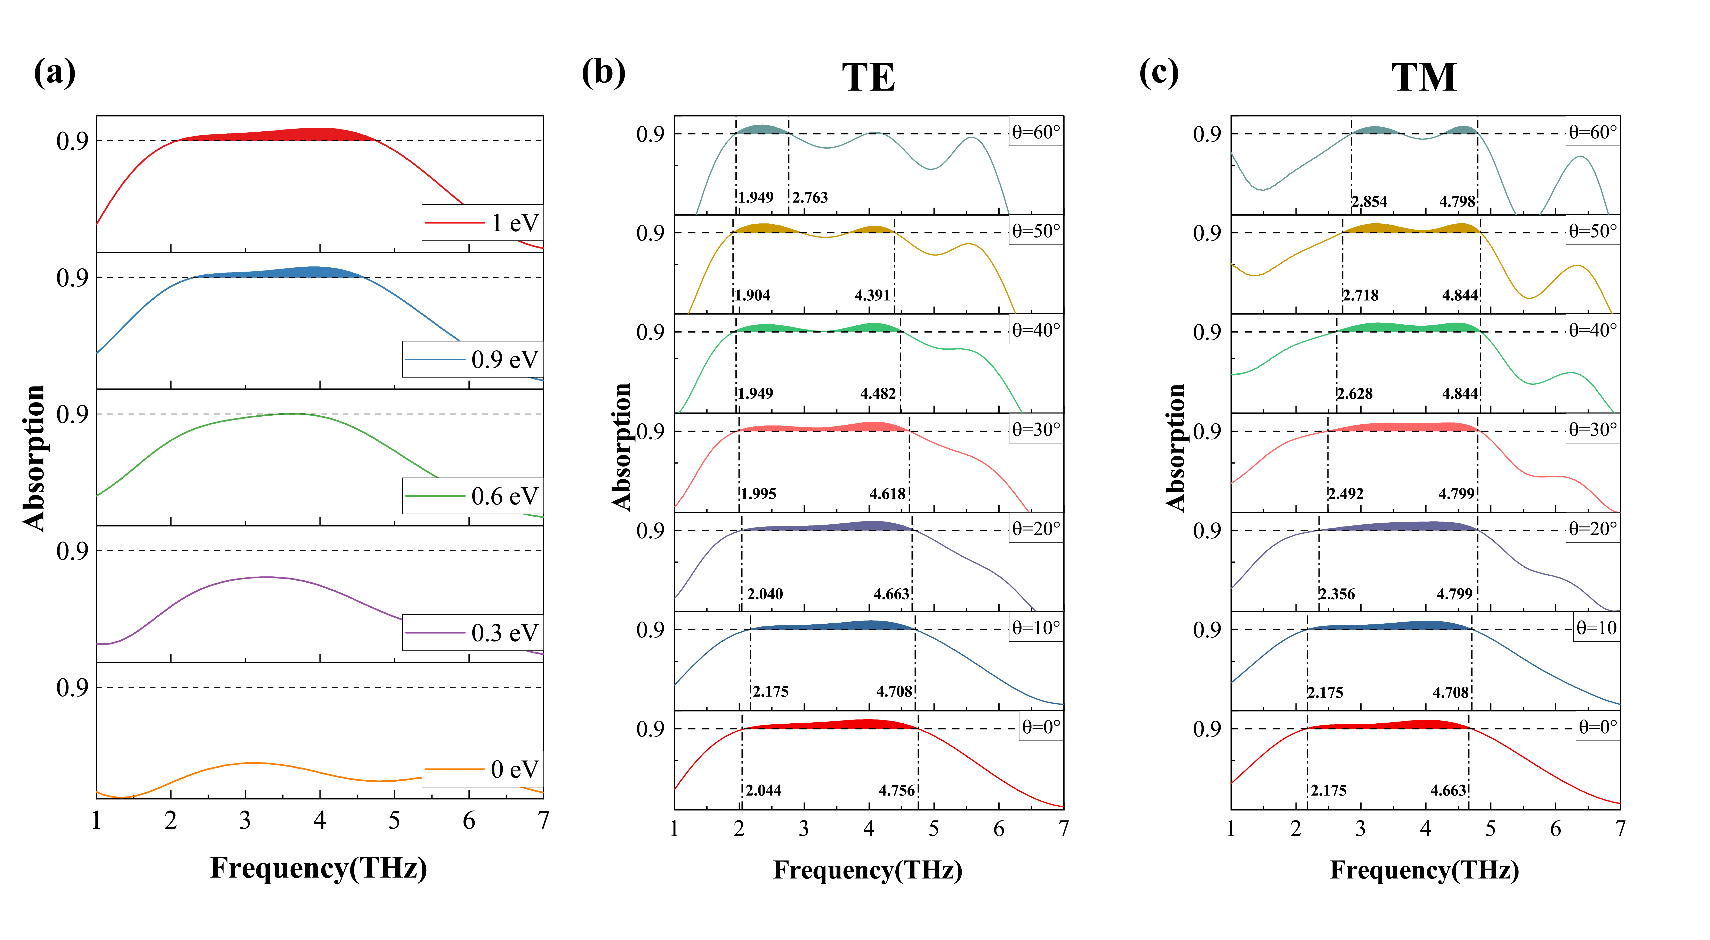

**Fig. 7.** (a)Absorption spectra of DSE with the chemical potentials is tuned from 0 eV to 1 eV. Absorption spectra with different incident angle of (b) TE (c) TM polarization incident.

1. *Compare with other publications*

**Tab. 3** Compare with other publications

|  |  |  |  |  |
| --- | --- | --- | --- | --- |
| Reference | Absorption bandwidth (THz) | Conversion Mode | Conversion Band (THz) | Conversion Type |
| Work 140 | 0.07(**+**[1]) & 0.41(-) | R (**+**) & T (-) | 0.75~1.15(**+**) & 1.0(-) | LTX & RHCP[2] |
| Work 241 | peak at 1.4 & 2.13 | T | 2.05~2.38 &3.38~3.68 | AT[3] |
| Work 342 | 2.09 | R | 1.1~3.2 | LTX |
| This Work | 2.668 | T | 6.241~10 | LTX |

To underscore the benefits of our DSE design, we compared its performance against recent state‑of‑the‑art metasurface architectures from international journals in Table 3. Our DSE not only delivers superior absorption and polarization‑conversion bandwidths but also leverages machine‑learning‑guided optimization to systematically identify quasi‑optimal structural parameters, driving these performance gains.

1. Conclusion

This study demonstrates a machine learning-driven metasurface design framework through the development of a dual-functional terahertz device DSE. By Employ Random Forest algorithms, we achieved high-accuracy prediction with the *R*² score up to 0.98, for the polarization conversion bandwidth of 3.759 THz and the effective absorption bandwidth of 2.668 THz. Beyond its broadband performance, the DSE architecture exhibits polarization insensitivity, high-angular incident stability, absorption tunability, and dual-functional integration. The ML assisted optimization strategy reduces parametric search iterations compared to conventional methods, establishing a scalable paradigm for intelligent metasurface design.

ACKNOWLEDGMENTS

Fundamental Research Funds for Jiangsu Provincial Key Research and Development Program (BE2022391).

DATA AVAILABILITY

The data that supports the findings of this study are available from the corresponding author upon reasonable request.

References

1. M. Wang, H. Li, Y. Dong, G. Li, B. Jiang, Q. Zhao and J. Xu, IEEE Trans. Antennas Propag. **64** (1), 286–290 (2015).

2. O. Smolyanskaya, N. Chernomyrdin, A. Konovko, K. Zaytsev, I. Ozheredov, O. Cherkasova, M. Nazarov, J.-P. Guillet, S. Kozlov and Y. V. Kistenev, Prog. Quantum Electron. **62**, 1–77 (2018).

3. Y. Zhang, S. Qiao, S. Liang, Z. Wu, Z. Yang, Z. Feng, H. Sun, Y. Zhou, L. Sun and Z. Chen, Nano Lett. **15** (5), 3501–3506 (2015).

4. W. Talataisong, J. Gorecki, L. D. van Putten, R. Ismaeel, J. Williamson, K. Addinall, D. Schwendemann, M. Beresna, V. Apostolopoulos and G. Brambilla, Photonics Res. **9** (8), 1513–1521 (2021).

5. S. Kim and A. Zajić, IEEE Trans. Wireless Commun. **15** (9), 6423–6433 (2016).

6. Z. He, L. Li, H. Ma, L. Pu, H. Xu, Z. Yi, X. Cao and W. Cui, Results Phys. **21**, 103795 (2021).

7. S. Li, J. Ma, X. Wu, B. Zhang, C. Ouyang, T. Wang, D. Wang, X. Wang and Y. Li, Chin. Opt. Lett. **19** (5), 051901 (2021).

8. H. Rajabalipanah, K. Rouhi, A. Abdolali, S. Iqbal, L. Zhang and S. Liu, Nanophotonics **9** (9), 2861–2877 (2020).

9. Y. Wang, D. Zhu, Z. Cui, L. Yue, X. Zhang, L. Hou, K. Zhang and H. Hu, IEEE Trans. Terahertz Sci. Technol. **10** (6), 599–605 (2020).

10. S. Taravati and G. V. Eleftheriades, ACS Photonics **9** (2), 305–318 (2022).

11. K. Zhang, Y. Wang, S. N. Burokur and Q. Wu, IEEE Trans. Microwave Theory Tech. **70** (1), 200–209 (2021).

12. J. Zhang, X. Wei, I. D. Rukhlenko, H.-T. Chen and W. Zhu, ACS Photonics **7** (1), 265–271 (2019).

13. H. Wei, T. Ji and J. Huang, J. Renewable Mater. **11** (2), 731–743 (2023).

14. Z. Chen, J. Chen, H. Tang, T. Shen and H. Zhang, Opt. Mater. Express **13** (2), 514–525 (2023).

15. X. Tao, L. Qi, J. Yang, J. A. Uqaili, F. Lan and Z. Yang, IEEE Trans. Terahertz Sci. Technol. **13** (3), 254–261 (2023).

16. G. Wang, S. Zuo, J. Liu, X. Zhang, M. Li, S. Yang, Y. Jia and Y. Gao, Phys. Chem. Chem. Phys. **25** (29), 19719–19726 (2023).

17. H. Zhang, X. He, D. Zhang and H. Zhang, Opt. Express **30** (13), 23341–23358 (2022).

18. Z. Song and J. Zhang, Opt. Express **28** (8), 12487–12497 (2020).

19. J. Hou, J. Jin, H. Lin, Z. Liu, J. Fu and F. Feng, presented at the 2023 IEEE MTT-S International Conference on Numerical Electromagnetic and Multiphysics Modeling and Optimization (NEMO), 2023 (unpublished).

20. Y. Chen, Q. Wang, Z. Han, W. Li, M. Shi and G. Zhao, Phys. Scr. **99** (10), 105506 (2024).

21. F. Su, D. Luong, I. Lam, S. Rajan and S. Gupta, presented at the 2023 IEEE Sensors Applications Symposium (SAS), 2023 (unpublished).

22. P. Liu, Z. Shan and Z. N. Chen, presented at the 2023 17th European Conference on Antennas and Propagation (EuCAP), 2023 (unpublished).

23. Y. Qiu, S. Chen, Z. Hou, J. Wang, J. Shen and C. Li, Micromachines **14** (4), 789 (2023).

24. W. Chen, Y. Gao, Y. Li, Y. Yan, J. Y. Ou, W. Ma and J. Zhu, Adv. Sci. **10** (13), 2206718 (2023).

25. Y. Zhang, Y. Feng, B. Zhu, J. Zhao and T. Jiang, Opt. Express **22** (19), 22743–22752 (2014).

26. Z. Y. Song and J. H. Zhang, Opt. Express **28** (8), 12487–12497 (2020).

27. Y. Zhu, Y. Zhao, M. Holtz, Z. Fan and A. A. Bernussi, J. Opt. Soc. Am. B: Opt. Phys. **29** (9), 2373–2378 (2012).

28. S. X. Wang, L. Kang and D. H. Werner, Sci. Rep. **7** (2017).

29. Y. Harada, M. S. Ukhtary, M. Wang, S. K. Srinivasan, E. H. Hasdeo, A. R. Nugraha, G. T. Noe, Y. Sakai, R. Vajtai and P. M. Ajayan, ACS Photonics **4** (1), 121–126 (2017).

30. Q. Zhou, P. Liu, L.-a. Bian, H. Liu, C. Liu and G. Chen, Opt. Commun. **413**, 310–316 (2018).

31. H.-T. Zhang, L. Zhang, D. Mukherjee, Y.-X. Zheng, R. C. Haislmaier, N. Alem and R. Engel-Herbert, Nat. Commun. **6** (1), 8475 (2015).

32. G. Biau, J. Mach. Learn. Res. **13** (1), 1063–1095 (2012).

33. K. Fawagreh, G. M. Medhat and E. and Elyan, Systems Science & Control Engineering **2** (1), 602–609 (2014).

34. B. Mallala, A. I. U. Ahmed, S. V. Pamidi, M. O. Faruque and R. R. M, Results Eng. **25**, 103789 (2025).

35. Y. Zhang, A. E. Hartemink and J. Huang, Geoderma **389**, 114961 (2021).

36. C. Zheng, C. Chen, Y. Chen and S. P. Ong, Patterns (New York, N.Y.) **1** (2), 100013 (2020).

37. R. Perfetti and E. Ricci, IEEE Trans. Neural Networks **17** (4), 1085–1091 (2006).

38. Y.-c. Wu and J.-w. Feng, Wireless Personal Communications **102** (2), 1645–1656 (2018).

39. F. Qin, Z. Chen, X. Chen, Z. Yi, W. Yao, T. Duan, P. Wu, H. Yang, G. Li and Y. Yi, Nanomaterials **10** (2), 207 (2020).

40. X. S. Bai, Y. X. Wang, Y. J. Zhao, J. P. Tian, W. M. Zhang and R. C. Yang, Optics and Laser Technology **182** (2025).

41. G. Wang, S. Y. Zuo, J. Liu, X. Zhang, M. C. Li, S. Yang, Y. Jia and Y. C. Gao, Phys. Chem. Chem. Phys. **25** (29), 19719–19726 (2023).

42. Y. Zhang, W. R. Xue, Y. D. Du, J. L. Liang and C. Y. Li, Opt. Mater. **149** (2024).

1. + and - means the forward and backward
2. RHCP means Right-Handed Circularly Polarized
3. AT means Asymmetric Transmission